Branch | Document # | Location of Shutdown | Date of Shutdown
Wastewater Services | Sample OSS 1 | Lift Station Name | Proposed date and time

Section 1: Purpose
Describe the purpose of the planned shutdown.
* Temporary Station Shutdown for Temporary Power Service Connection (1 hour) *

Lift Station Name will be completely offline while the Electrician makes a connection inside 600V cabinet.

Contractor name, subcontractor name and Collections Crew to remain on site for the duration of the shutdown.

Section 2: Stakeholders
List all relevant stakeholders that will be involved or at a minimum, must be kept informed, of the shutdown and related activities.
Note: changes to this list by any stakeholder should be communicated to the team 24hrs in advance

Owner: City of Winnipeg | Role | Phone # | Cell #
Wastewater Control | McPhillips Control Centre | Number
City Name | Superintendent of WW Collection |  | Number
City Name | Project Coordinator |  | Number
City Name | Supervisor of Regional WW Collection |  | Number
City Name | D&C Inspector |  | Number
City Name | City Project Manager |  | Number
Contract Administrator: Consultant Name | Role | Phone # | Cell #
Contract Admin Name | Contract Administrator |  | Number
Contract Admin Rep Name | Discipline Representative |  | Number
* Call order as listed below (response time +/- 45 min. after call is acknowledged)
** Modeled time to overflow = 2.75 hrs with temporary 300mm weir in place.
Contractor: Name | Role | Phone # | Cell #
Contractor Name | Construction Site Supervisor |  | Number
Contractor Name | Project Manager |  | Number
subContractor: Name | Role | Phone # | Cell #
subcontractor Name | Electrical Site Supervisor |  | Number
subcontractor Name | Electrical Project Manager |  | Number

Section 3: Risks and Contingency Planning
List all potential risks associated with the planned shutdown. Develop contingency plans to address risks. Hit tab in lowest right cell to add additional lines.
Risk | Contingency Plan
Overflow to the Environment Risk  Under normal dry weather flow, typical pump OFF time is approximately 1 hour.  Hydro work could take > 1hour | Service cable swap inside the building is expected to take <30 minutes. Once complete, the station can be operated on Contractor Name generator.  Contractor Name has raised the weir by 300mm to add more storage, and the City shall close the slide gate as a precaution  Contractor Name will be responsible for cleaning the outfall chamber between the weir and the slide gate prior to opening the slide gate, if water happens to overflow the weir
Generator not working as intended | Manitoba Hydro shall not permanently disconnect the existing service cables until the station is confirmed to be operating properly under generator power. If required, utility cabling inside the building can be reinstated in <30 minutes.  Work by Manitoba Hydro, Coordinated with Contractor Name

Section 4: Shutdown Plan
Outline the shutdown plan. Include all related tasks, timelines, communication planning, etc.
* 600V Generator to be installed and ready for service prior to shutdown [Contractor Name]

- Contractor Name has installed a 300mm high weir in Metcalfe Outfall Chamber as per Appendix A. [Contractor Name]
  - Weir should allow for 2hr 45min time to overflow, as modeled by City
- Contractor Name, City, Contract Admin to review incoming flow rates and predicted weather forecast prior to proceeding with the shutdown [Contractor Name, City, Contract Admin Name]
- Collections crew to manually draw down wetwell as far as possible [City]
- City to close slide gate as a precaution [City]
- MB Hydro to disconnect power to the building but leave service cabling intact [Hydro]
- subContractor Name disconnect utility cabling in station, connect new temporary cabling [subContractor Name]
- Connect Station to generator power through the manual transfer switch [subContractor Name]
- Collections to confirm station operation [City]
- Once #6 is confirmed, MB Hydro to swing utility power over to temporary service [Hydro]

- subContractor Name to switch Station back to utility power using manual transfer switch [subContractor Name]
- Collections to confirm station operation [City]
- If required, pump out and clean the outfall chamber between the weir and the slide gate [Contractor Name]
- City to open slide gate [City]

*** Contractor Name, subContractor Name, and Collections Crew to remain on site for the duration of the shutdown.

Section 5: Monitoring
Describe any monitoring required leading up to, during, and following the shutdown.
- Monitor wastewater level in the wetwell using existing level sensor. RTU has battery backup for periods with no power. [Contractor Name & City]

- If level sensor not available, monitor wastewater level in first upstream manhole of station (just outside station). [Contractor Name & City]

* See section 6: Key Data for relevant monitoring information

Section 6: Key Data
Describe data required for shutdown planning and monitoring purposes.
System Storage | 2.75 Hours (estimated/modeled)
Normal Pump ON | 220.777 (3.25 ft Local)
High Level | 223.030 (4.14 ft Local)
Overflow Weir | 223.630 (8.12 ft Local) ** temporary modified height
Monitoring MH located just outside the door of the station
Monitoring MH Rim | 231.51 m
Monitoring MH Inv | 221.99 m
Monitoring MH Measurements – Rim to top of water
High Level | 8.48 m (27.8 ft)
Overflow to Environment | 7.88 m (25.85 ft)

STORAGE CALCULATION TIME
(Info provided by the City based on their latest InfoWorks Hydraulic Model)
After reviewing the Lift Station Name catchment in the model, there is an area in St. Boniface, just west of the Seine River that is not accurately represented in the model network. Reviewing GIS and record drawings, it looks like a significant portion of this area drains to Lift Station Name. The City has made internal updates to try and account for the missing population in the model simulations ran, based on our best population estimates. Please be aware that the information below is based on an incomplete model representation of the catchment area:
Description/Condition | Existing Weir | Weir + 300 | Weir + 900
Time to Overflow (positive gate open): | 45 min | 2.75 hrs | 17 hrs
Time to Basement flooding (positive gate closed): | >48 hours | >48 hours | >48 hours
Weir Elevation (mASL): | 223.330 | 223.630 | 224.230

Critical Asset MH#: S-MH50002376
Critical Asset Location: Des Meurons @ Eugenie
Critical Asset Basement Flooding elevation: 226.70 mASL

Monitoring MH: S-MH50003713 (in front of flood pumping station)
Monitoring MH Chamber Floor elevation: 221.99 mASL
Monitoring MH Rim Elevation: 231.51 mASL

* Contractor Name will be using the Weir + 300 configuration (see Appendix A)

Section 7: Lessons Learned
Once shutdown is complete, meet with relevant stakeholders to review the shutdown. List what went well and what should be changed for future shutdowns.
What went well? | What should be changed for future shutdowns?

Section 8: Document Close
Closed by: | Date:

Appendix A
Weir Layout

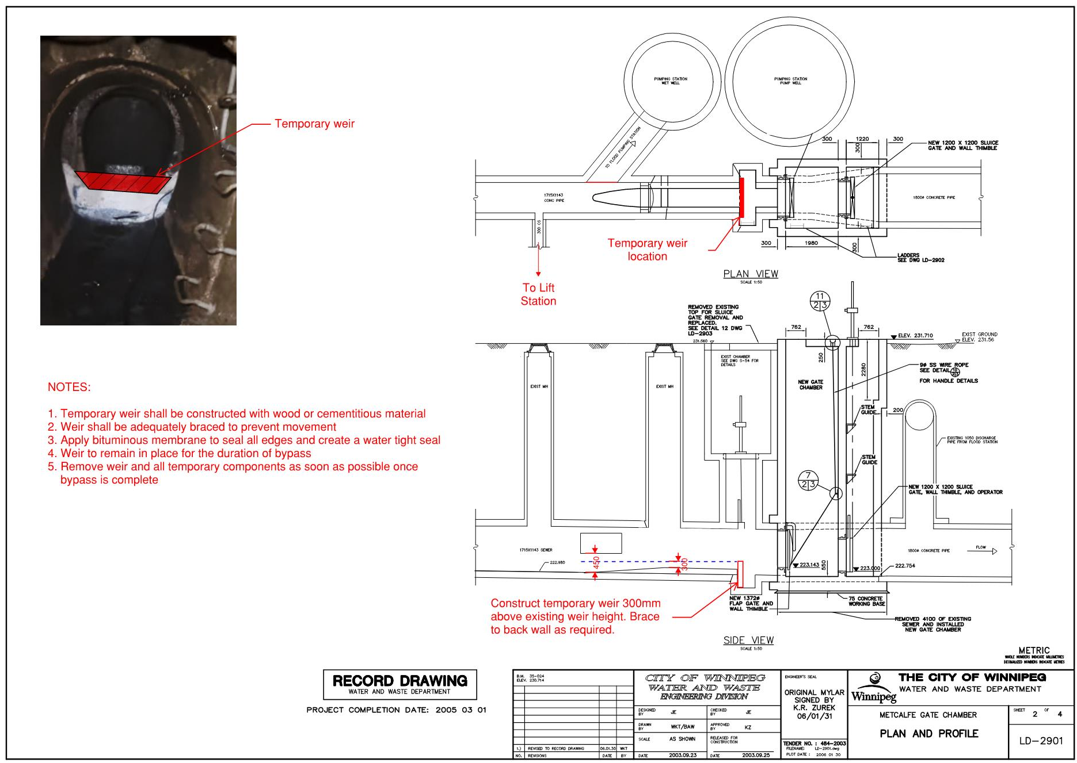

Appendix B
Generator

